Database Testing using Selenium

* A1 Driver Manager
* A2 Driver
* A3 Connection
* A4 Statement
* A5 ResultSet
* A6 SQLException
* **Three steps in DB Framework module**
* A1)Make connection to the database
* A2) Send Queries to the databaseA3) Process the results.

1) Make a connection to the Database

* Userid is the username configured in the database
* Password of the configured user
* URL is of format jdbc:< dbtype>://ipaddress:portnumber/db_name"
* <dbtype>- The driver for the database you are trying to connect. To connect to oracle database this value will be "oracle"For connecting to database with name "emp" in MYSQL URL will bejdbc:mysql://localhost:3036/emp

And the code to create connection looks likeConnection con = DriverManager.getConnection(dbUrl,username,password);You also need to load the JDBC Driver using the codeClass.forName("com.mysql.jdbc.Driver");2) Send Queries to the DatabaseOnce connection is made, you need to execute queries.You can use the Statement Object to send queries.Statement stmt = con.createStatement();Once the statement object is created use the executeQuery method to execute the SQL queriesstmt.executeQuery(select * from employee;);3) Process the resultsResults from the executed query are stored in the ResultSet Object.Java provides loads of advance methods to process the results. Few of the methods are listed below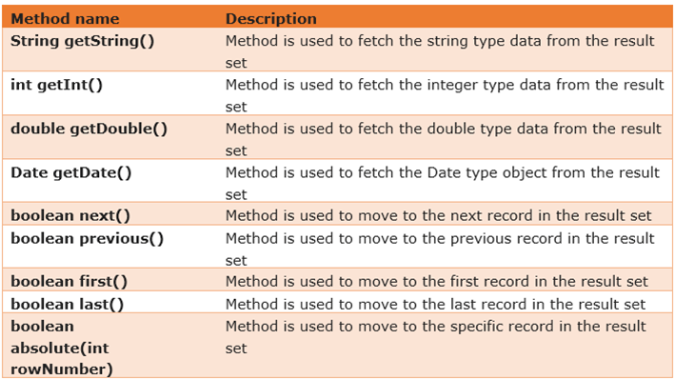Example of Database Testing with Selenium**Step 1)** Install [MySQL Server](http://dev.mysql.com/downloads/mysql/) and [MySQL Workbench](http://dev.mysql.com/downloads/workbench/)While installing MySQL Server, please note the database

* Username
* Password
* Port Number

It will be required in further steps.MySQL Workbench makes it easy to administer the database without the need to code SQL. Though, you can also use the MySQL Terminal to interact with the database.**Step 2)** In MySQL WorkBench, connect to your MySQL Server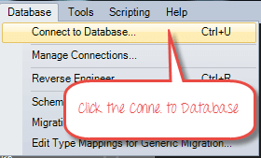 In the next screen,

1. Select Local Instance of MySQL
2. Enter Port Number
3. Enter Username
4. Enter Password
5. Click OK

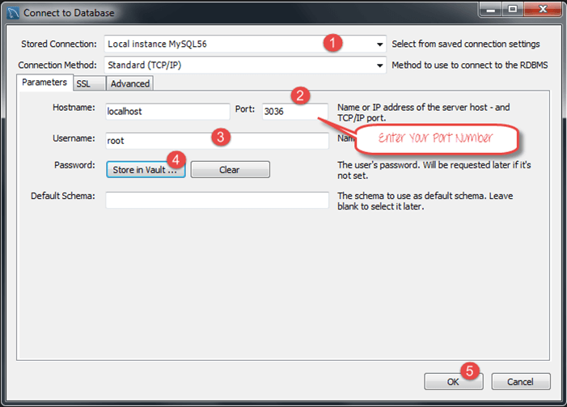**Step 3)** To Create Database,

1. Click create Schema Button
2. Enter Name of Schema/Database
3. Click Apply

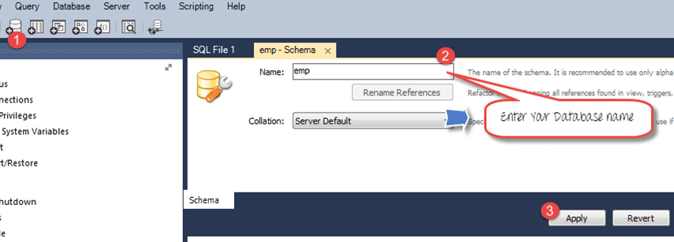**Step 4)** In the navigator menu,

1. Click on Tables, beneath the emp database
2. Enter Table name as employee
3. Enter Fields as Name and Age
4. Click Apply

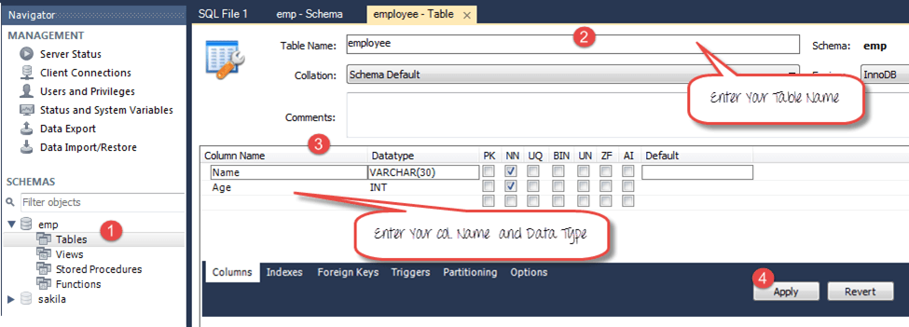You will see the following pop-up. Click Apply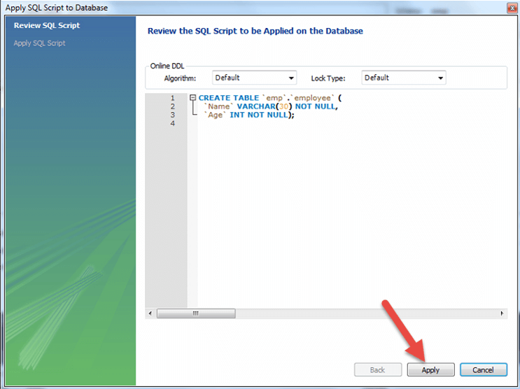**Step 5)** We will create following data

|  |  |
| --- | --- |
| Name | Age |
| Top | 25 |
| Nick | 36 |
| Bill | 47 |

To create data into the Table

1. In navigator, select the employee table
2. In right pane, click Form Editor
3. Enter Name and Age
4. Click Apply

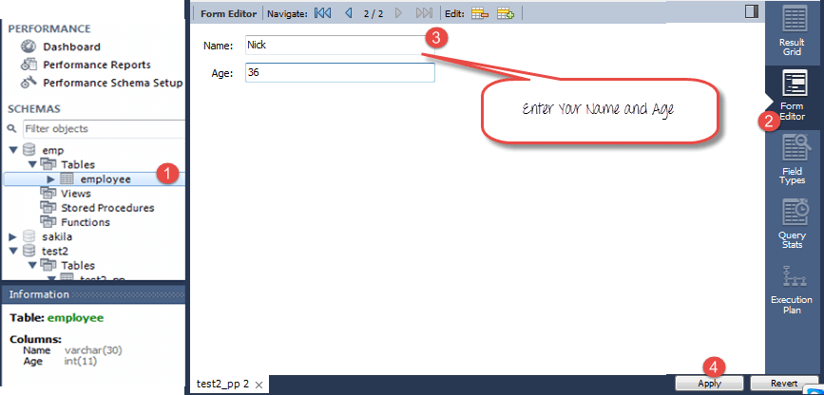

Repeat the process until all data is created

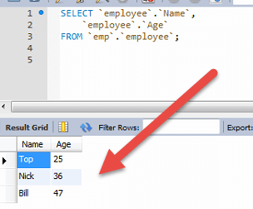

**Step 6)** Download the MySQL JDBC connector [here](https://code.google.com/p/find-ur-pal/downloads/detail?name=mysql-connector-java-5.1.18-bin.jar&)

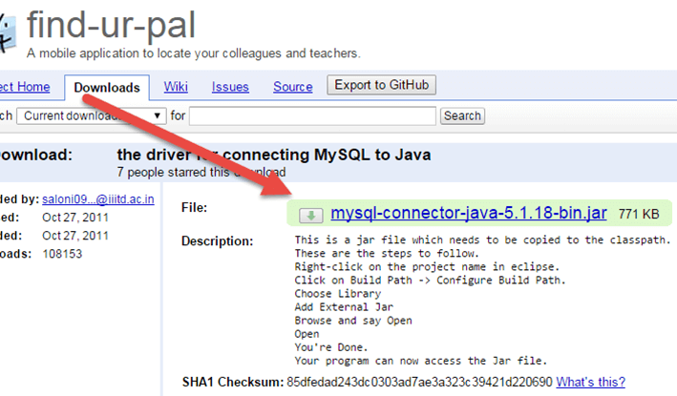

**Step 7)** Add the downloaded Jar to your Project

1. Right click on your Java File. Then click on Build Pathà Configure build path
2. Select the libraries
3. Click on add external JARs
4. You can see MySQL connector java in your library
5. Click on open to add it to the project

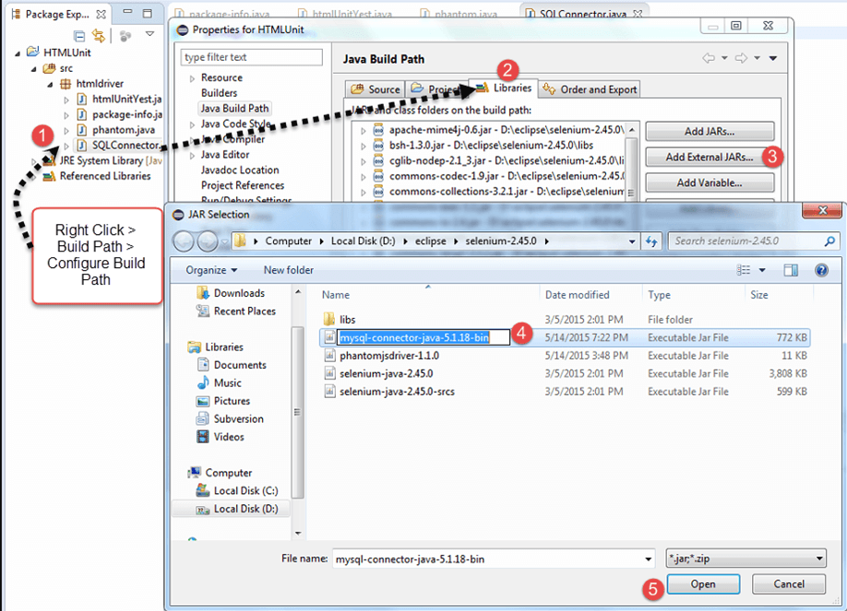

**Step 8)** Copy the following code into the editor

Package htmldriver;import java.sql.Connection;import java.sql.Statement;import java.sql.ResultSet;import java.sql.DriverManager;import java.sql.SQLException;public class SQLConnector { public static void main(String[] args) throws ClassNotFoundException, SQLException {//Connection URL Syntax: "jdbc:mysql://ipaddress:portnumber/db_name"String dbUrl = "jdbc:mysql://localhost:3036/emp";//Database UsernameString username = "root"; //Database PasswordString password = "guru99";//Query to ExecuteString query = "select * from employee;"; //Load mysql jdbc driverClass.forName("com.mysql.jdbc.Driver"); //Create Connection to DBConnection con = DriverManager.getConnection(dbUrl,username,password); //Create Statement ObjectStatement stmt = con.createStatement(); // Execute the SQL Query. Store results in ResultSetResultSet rs= stmt.executeQuery(query); // While Loop to iterate through all data and print resultswhile (rs.next()){String myName = rs.getString(1); String myAge = rs.getString(2); System. out.println(myName+" "+myAge); }// closing DB Connectioncon.close();}}

**Step 8)** Execute the code, and check the output

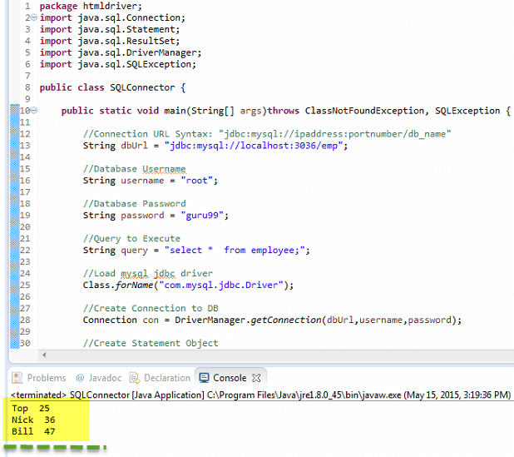

**Summary**

* In order to test Database using Selenium you need to
  1. Make a connection to the Database
  2. Send Queries to the Database
  3. Process the results
* The Syntax to connect to Database is
  + DriverManager.getConnection(URL, "userid", "password" )
* You will also need the Statement Object to send queries
  + Statement stmt = con.createStatement();
* To send the query to database use execute query and store the results in the ResultSet object
  + ResultSet rs = stmt.executeQuery(select * from employee;);
* Java provides lots of built-in methods to process the SQL Output using the ResultSet Object